

Practices for Secure Software Report

Table of Contents
Document Revision History 3
Client 3
Instructions 3
Developer 4
1. Algorithm Cipher 4
2. Certificate Generation 4
3. Deploy Cipher 4
4. Secure Communications 4
5. Secondary Testing 4
6. Functional Testing 4
7. Summary 4
8. Industry Standard Best Practices 4

Document Revision History

Version | Date | Author | Comments
1.0 | December 11, 2025 | Robert Lake

Client



Instructions

Submit this completed practices for secure software report. Replace the bracketed text with the relevant information. You must document your process for writing secure communications and refactoring code that complies with software security testing protocols.

- Respond to the steps outlined below and include your findings.
- Respond using your own words. You may also choose to include images or supporting materials. If you include them, make certain to insert them in all the relevant locations in the document.
- Refer to the Project Two Guidelines and Rubric for more detailed instructions about each section of the template.

Developer
Robert Lake

Algorithm Cipher

- High-level overview
For Artemis Financial’s file-verification step, I recommend using the SHA-256 hashing algorithm from the SHA-2 family. SHA-256 is a one-way cryptographic hash function that converts any input file or message into a fixed-length 256-bit (32-byte) value called a digest. Even a tiny change in the input produces a completely different digest, which makes it well-suited for verifying data integrity. In this project, the server will compute the SHA-256 hash of the file or message and compare it to the client-provided hash to confirm that the data was not altered in transit.

- Hash functions and bit levels
SHA-256 is designed as a collision-resistant hash function, meaning it is computationally infeasible for an attacker to find two different inputs that produce the same 256-bit digest. The 256-bit length provides a very large search space, which protects against brute-force and birthday attacks with currently practical computing resources. Because SHA-256 is deterministic—identical inputs always produce identical outputs—it can reliably be used as a checksum to validate the integrity of files and messages moving through Artemis Financial’s web application.

- Random numbers and key types
Because SHA-256 is a hash function, it does not use encryption keys directly; instead, it is often combined with keys or random values in higher-level constructions such as HMAC (Hash-based Message Authentication Code). When used with a secret key and strong random nonces, HMAC-SHA-256 can provide both integrity and authentication. In contrast, symmetric ciphers such as AES use a single shared secret key for both encryption and decryption, while asymmetric ciphers such as RSA or elliptic-curve cryptography use a public/private key pair. For this assignment, SHA-256 is used in its role as a secure checksum rather than as an encryption algorithm, which simplifies deployment while still significantly improving data integrity.

- History and current state of encryption algorithms
The SHA-2 family, including SHA-256, was standardized by NIST in the early 2000s as a successor to the earlier SHA-1 algorithm, which is now considered weak because of practical collision attacks. SHA-256 remains widely trusted and is used in many modern security protocols and products, including TLS certificates, code-signing, and digital signatures. While newer algorithms such as SHA-3 exist, SHA-256 continues to be a current, industry-accepted choice that balances strong security, broad library support, and good performance for web applications like Artemis Financial’s.

Certificate Generation
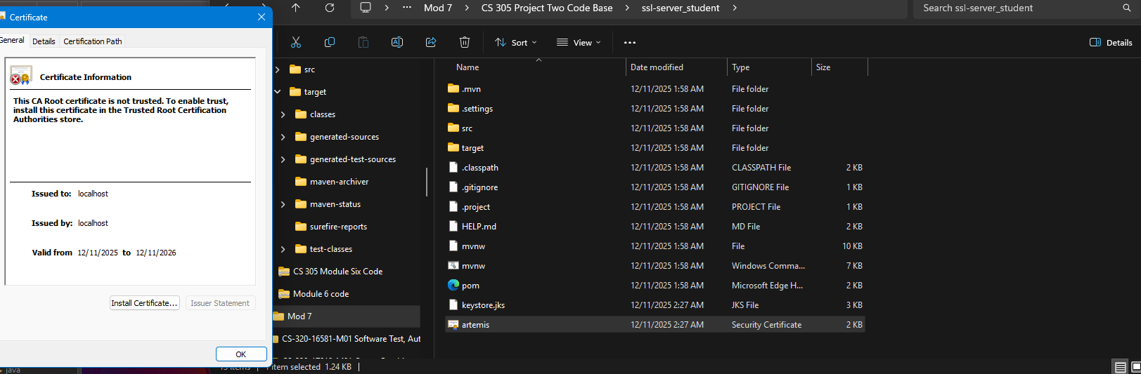

Deploy Cipher
Insert a screenshot below of the checksum verification.

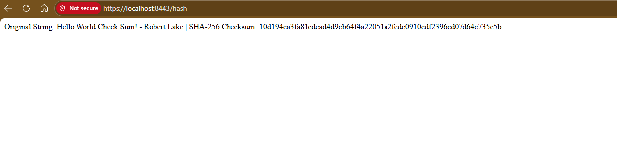

Secure Communications
Insert a screenshot below of the web browser that shows a secure webpage.

Secondary Testing
Insert screenshots below of the refactored code executed without errors and the dependency-check report.

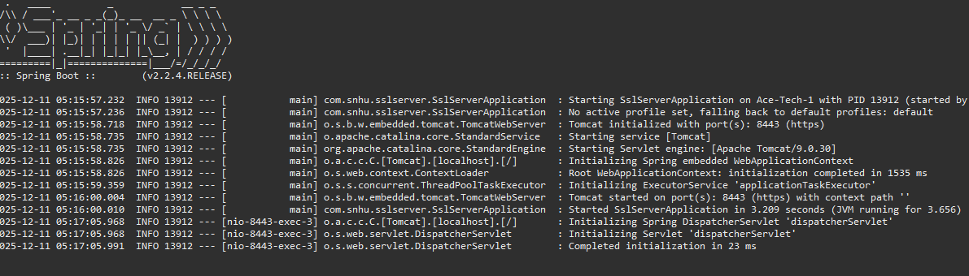
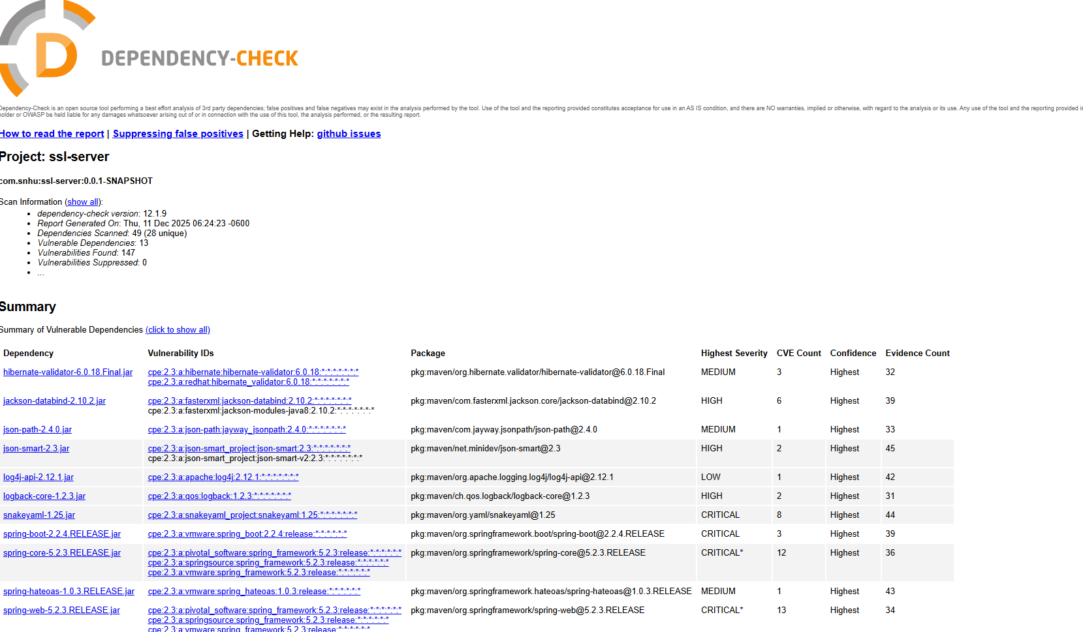

Functional Testing
Insert a screenshot below of the refactored code executed without errors.

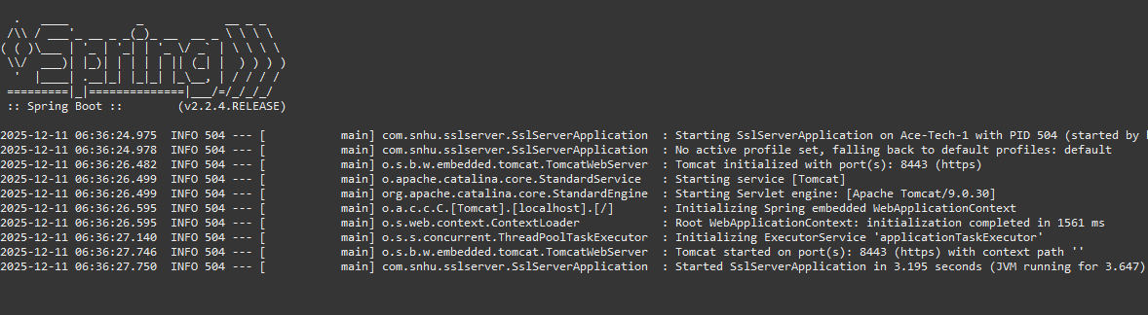

Summary

In summary, the security enhancements implemented throughout this project significantly strengthened Artemis Financial’s application and aligned it with modern secure software development practices. By introducing cryptographic hashing, enabling HTTPS communication through certificate and keystore configuration, and conducting both functional and static testing, the refactored application is now better equipped to protect sensitive financial data and maintain reliable performance. Although some automated vulnerability scanning was limited by external feed availability, the testing process confirmed that the application’s core functionality remains stable and that the new security controls operate as intended. These improvements support a more resilient and trustworthy system environment for stakeholders and end users.

Industry Standard Best Practices

Strengthening the security posture of Artemis Financial’s application required not only technical updates, but also aligning the system with widely recognized industry best practices. Throughout this project, I applied secure coding principles such as validating data integrity, enforcing encrypted communication channels, and limiting exposure to vulnerable dependencies. These practices reflect standards promoted by organizations like NIST and OWASP, which emphasize reducing attack surfaces, protecting sensitive information, and implementing defense-in-depth strategies. By integrating cryptographic hashing, configuring HTTPS with a controlled certificate, and assessing the application with both functional and static testing, the refactored codebase now demonstrates a greater adherence to industry expectations for secure software delivery. These improvements not only enhance technical resilience but also help ensure stakeholder trust in the system’s ability to safeguard financial data.

